1. Solr – HomePage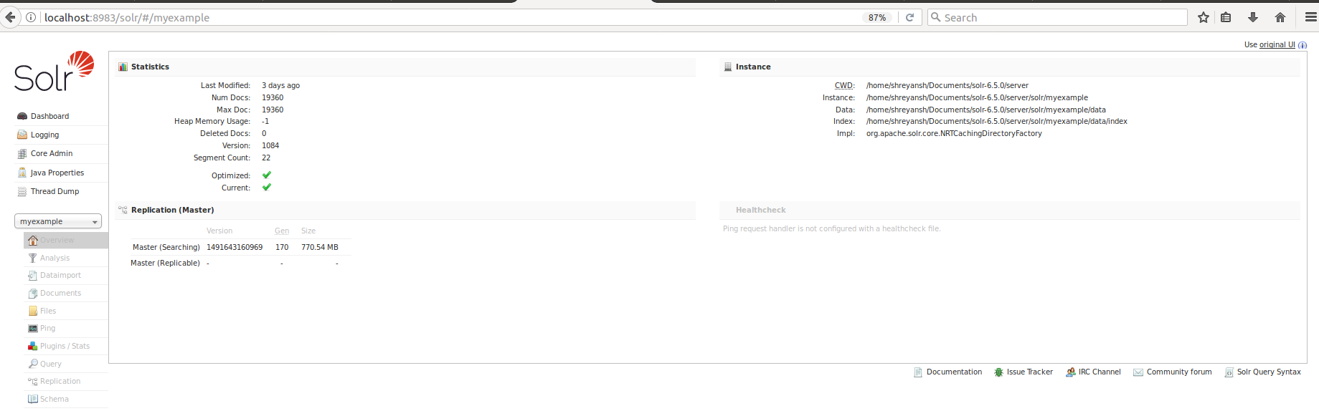
2. Brexit – Lucene - World

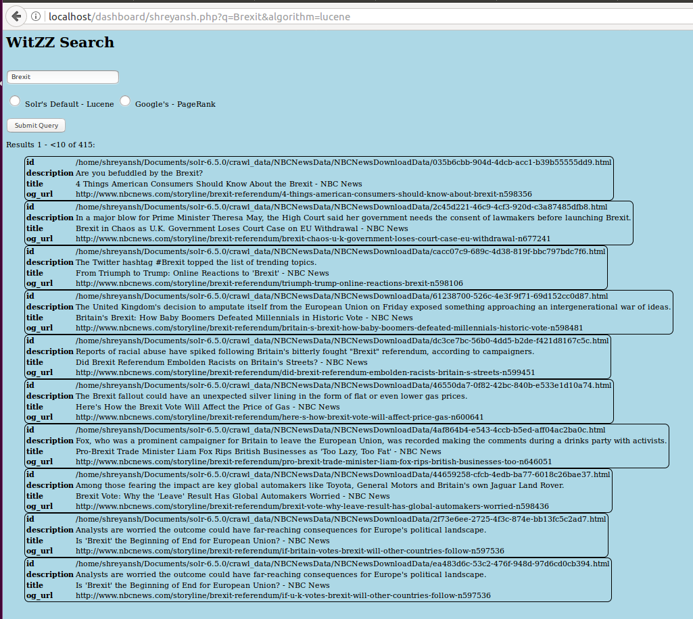

1. Brexit – PageRank - World

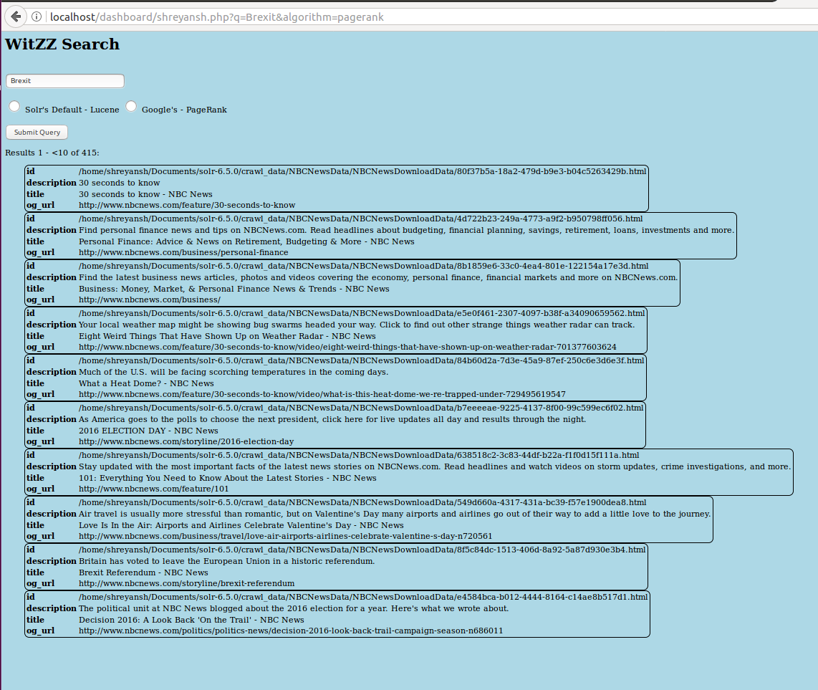

1. Brexit – NBC - World

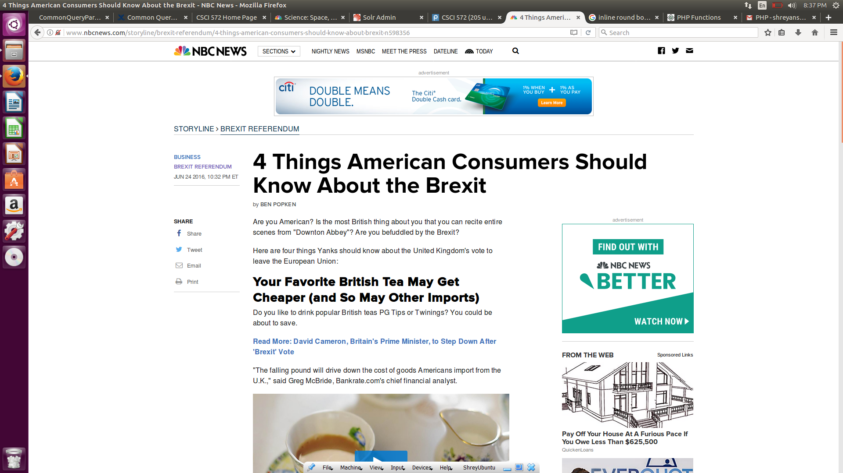

1. NASDAQ – Lucene - Business

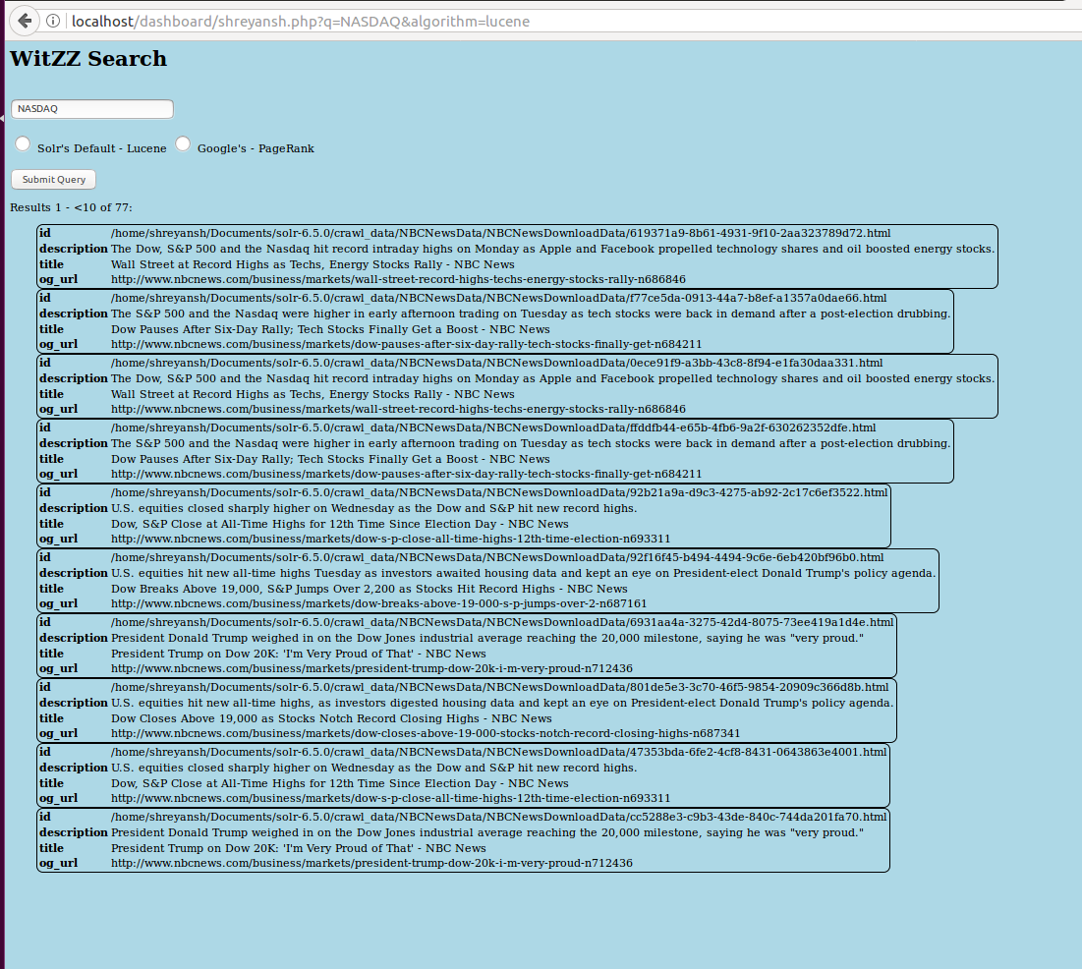

1. NASDAQ – PageRank - Business

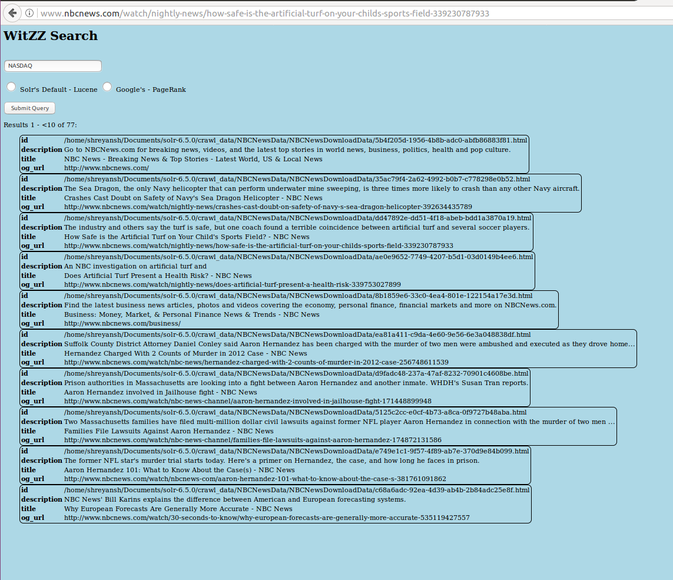

1. NBA – Lucene - Sports

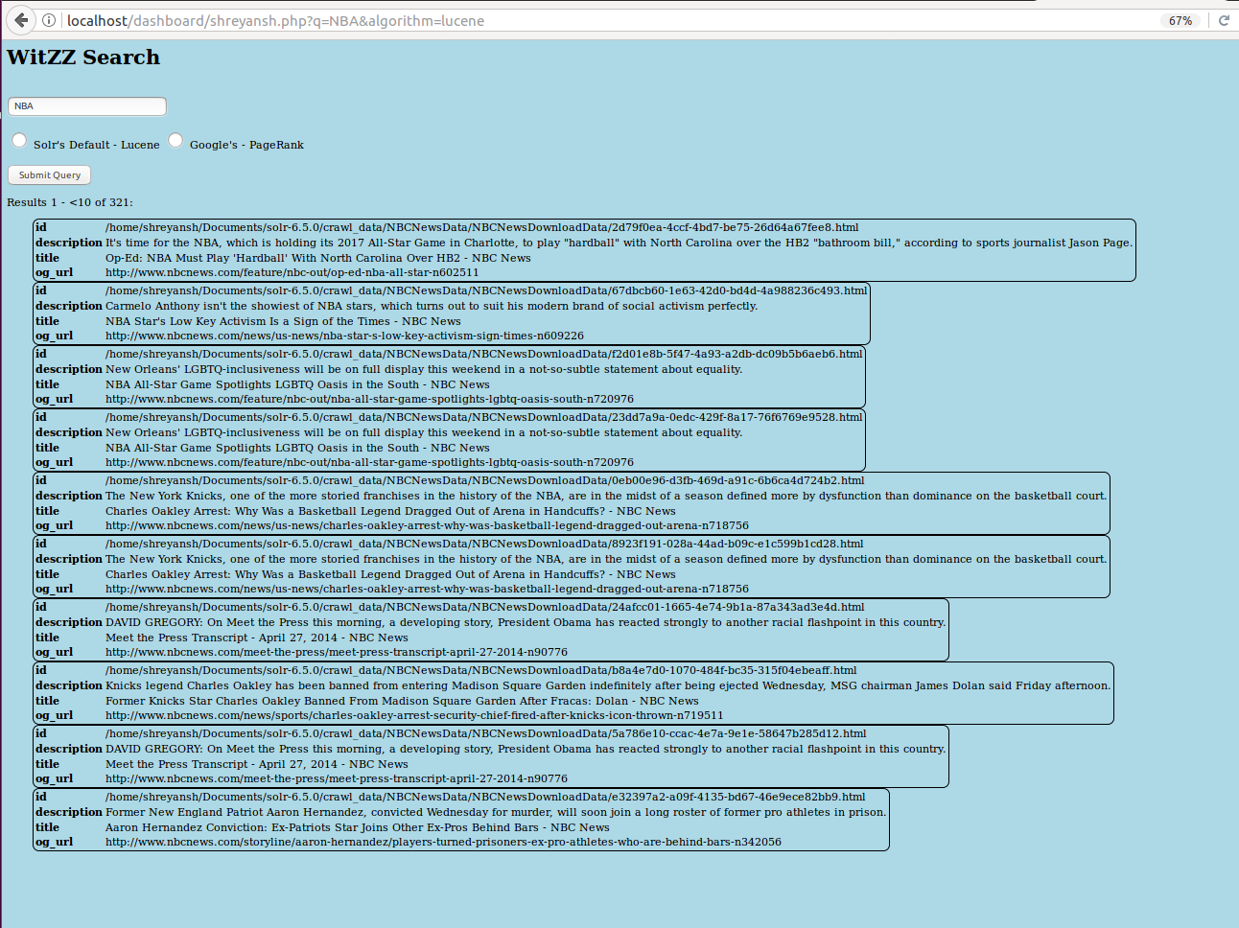

1. NBA – PageRank - Sports

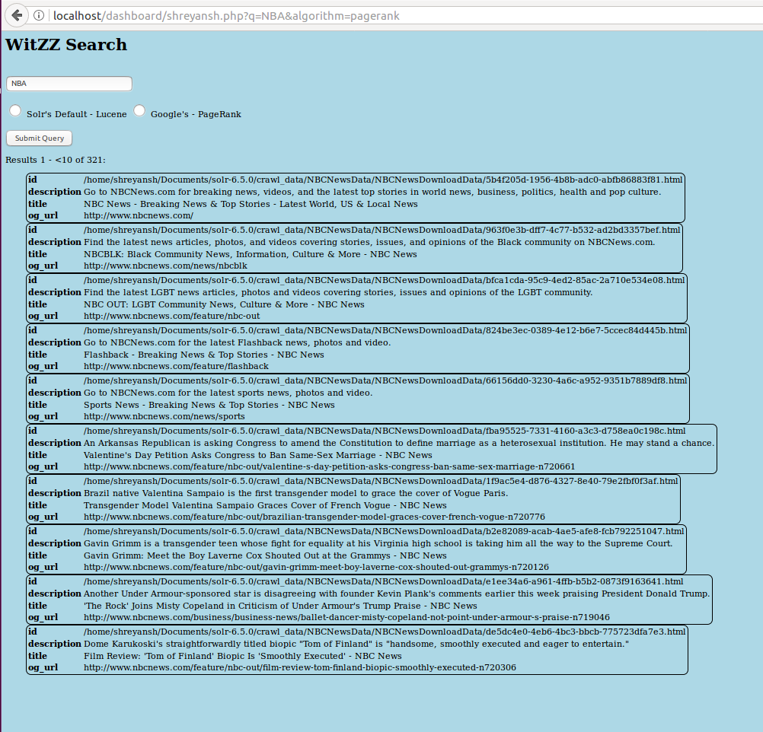

1. Snapchat – Lucene - Tech

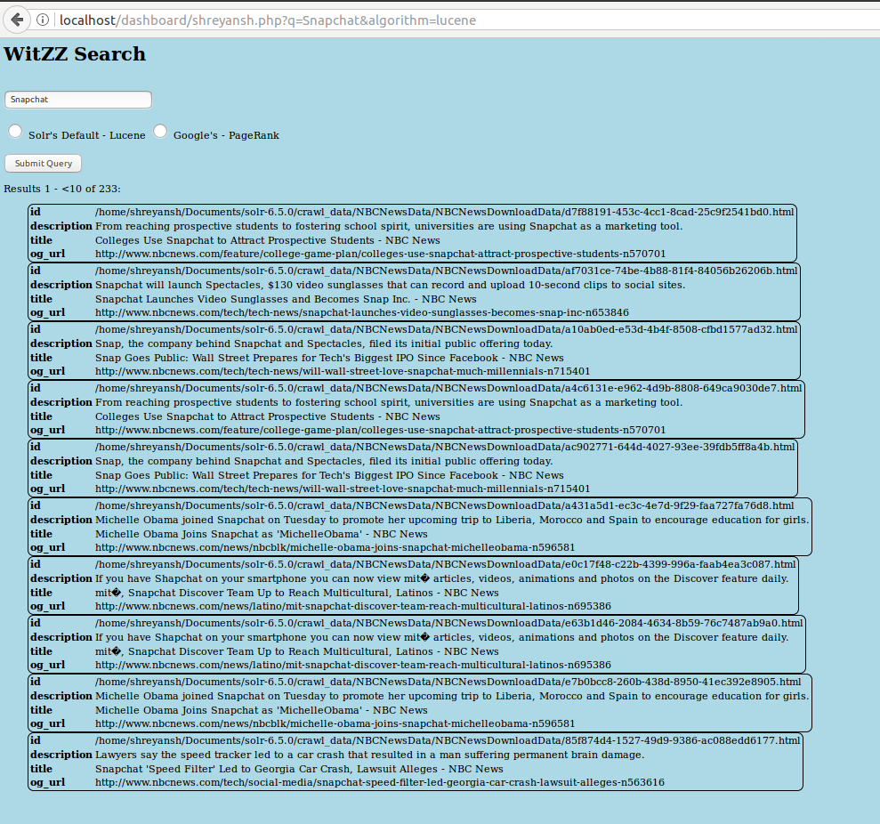

1. Snapchat – PageRank - Tech

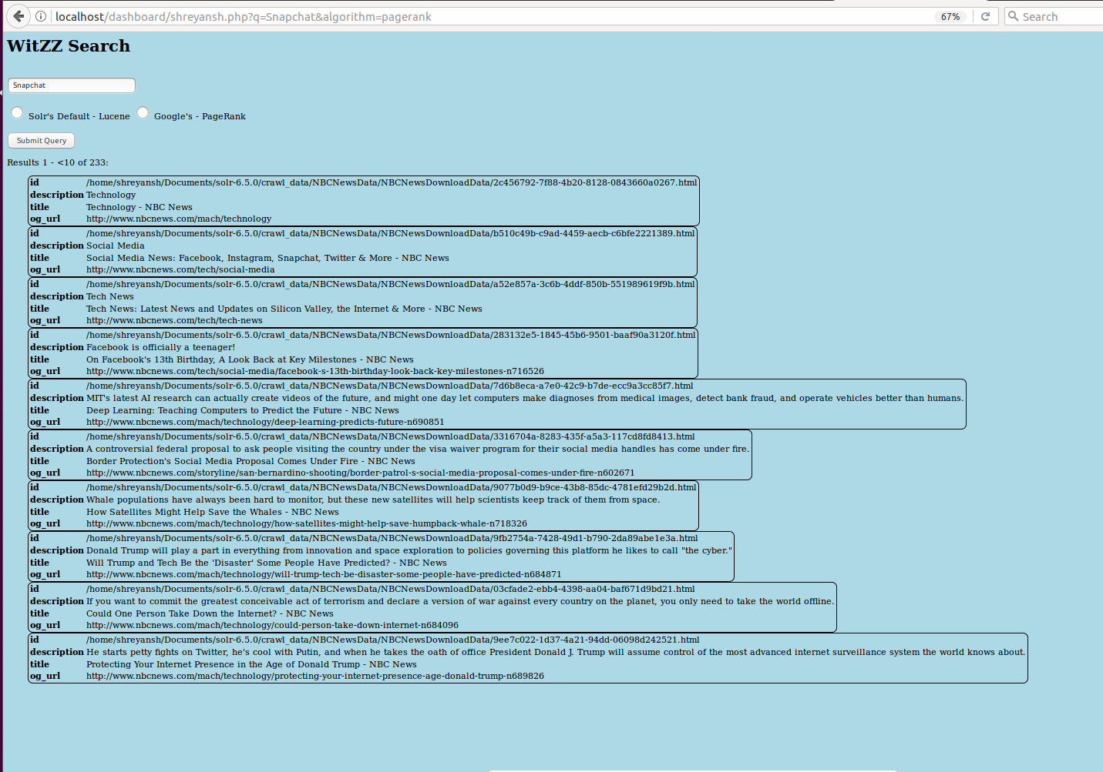

1. Snapchat – Link - Tech

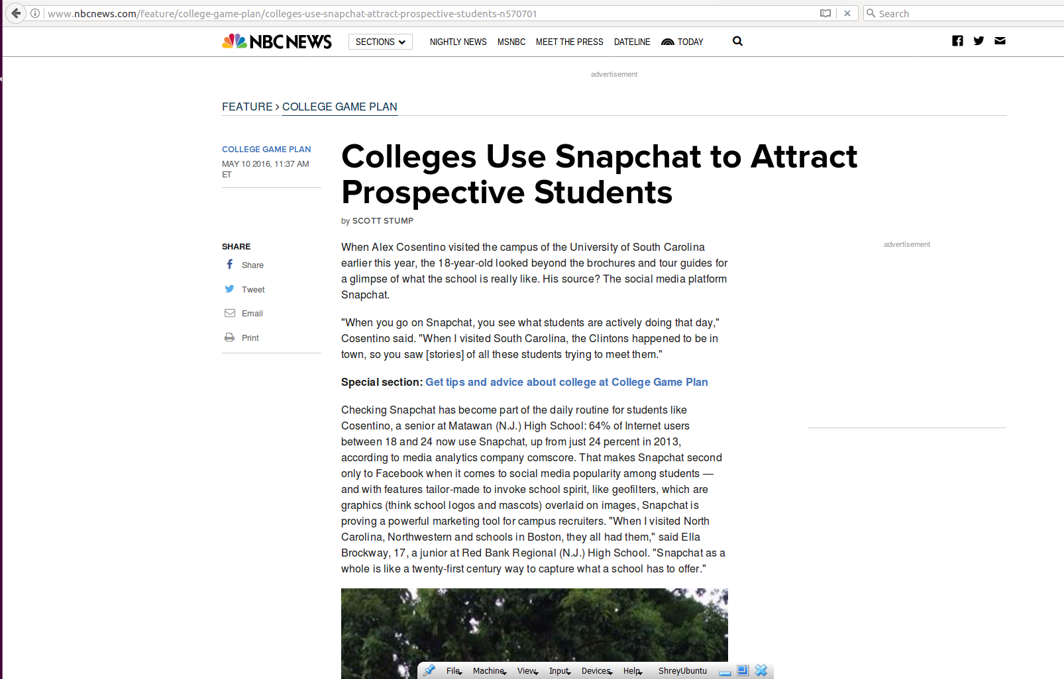

1. Illegal Immigration – Lucene - Opinion

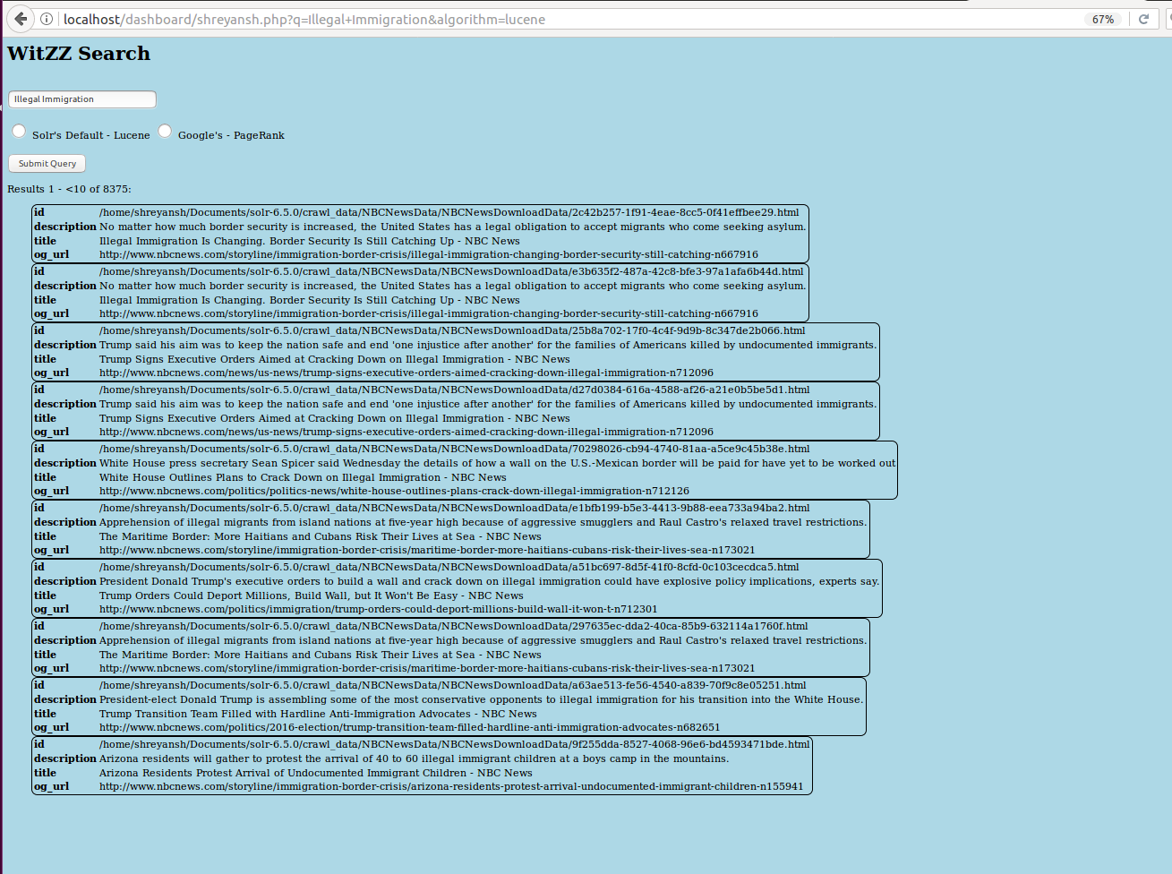

1. Illegal Immigration – PageRank - Opinion

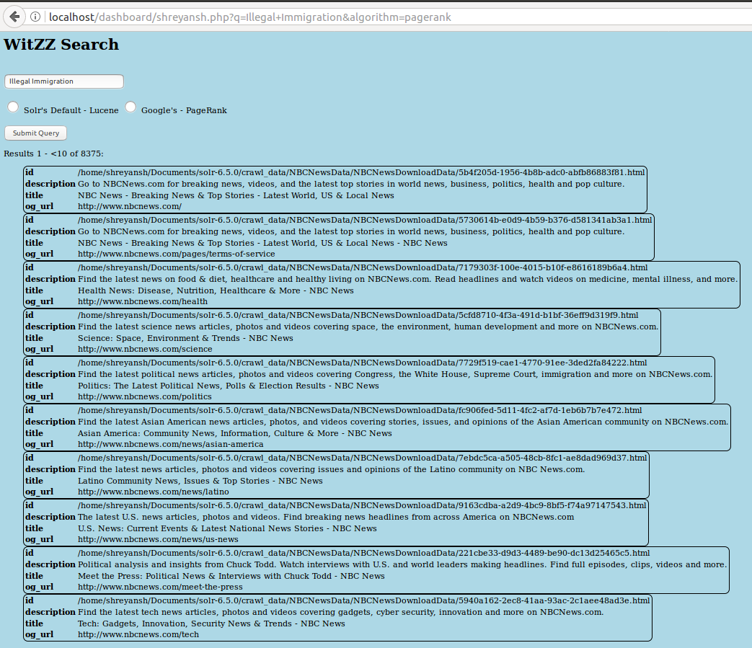

1. Donald Trump – Lucene - Politics

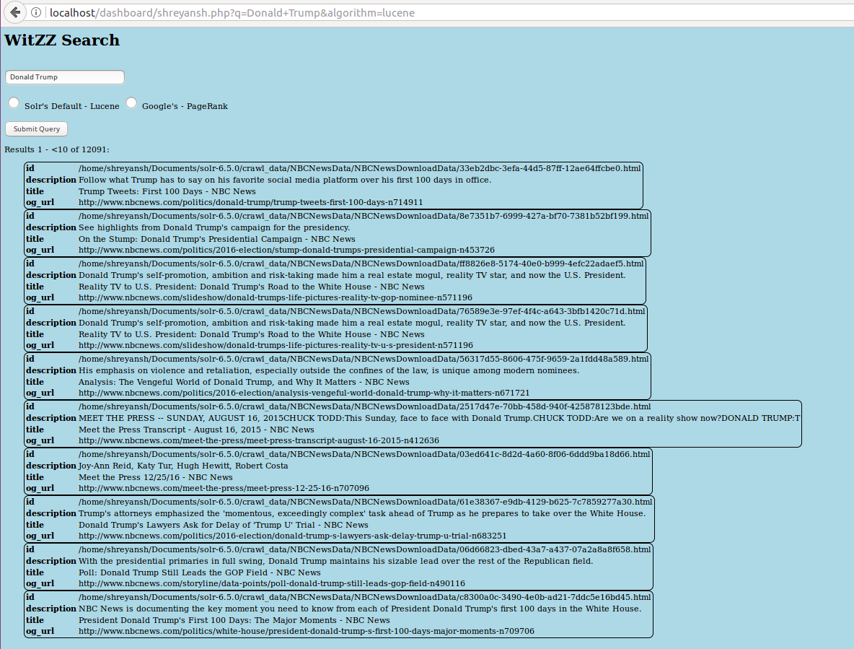

1. Donald Trump – PageRank - Politics

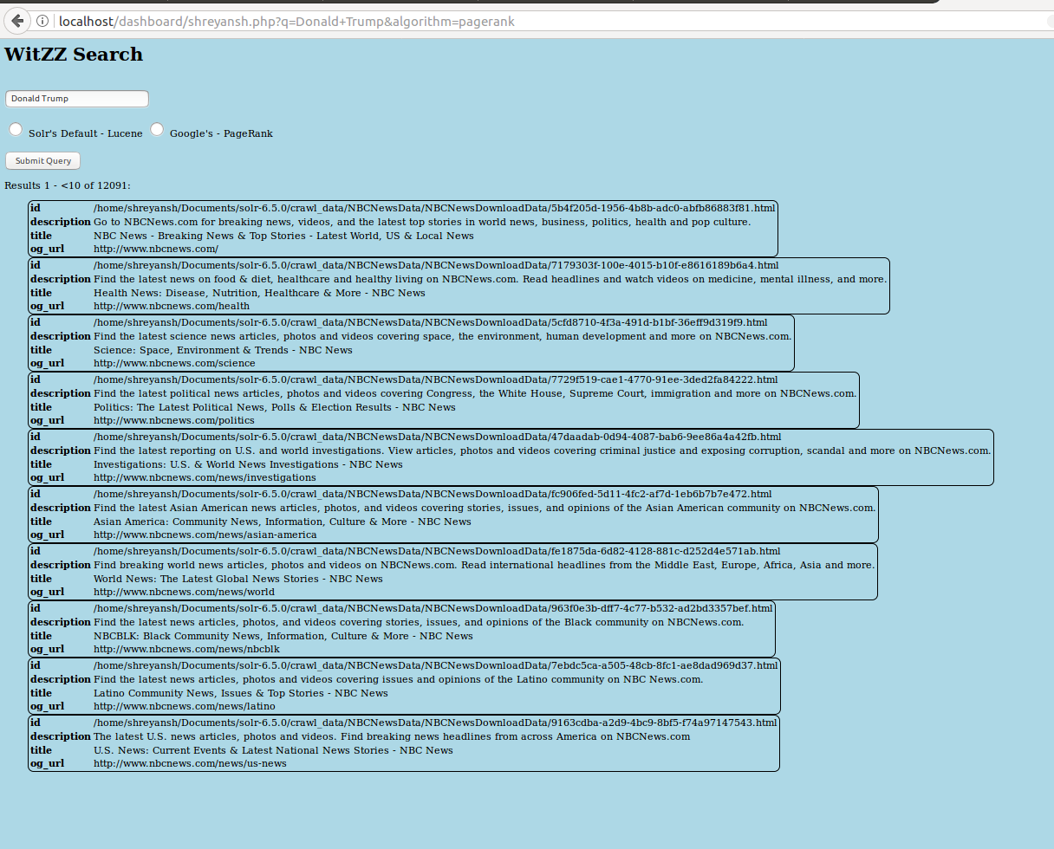

1. Russia -Lucene - Nation

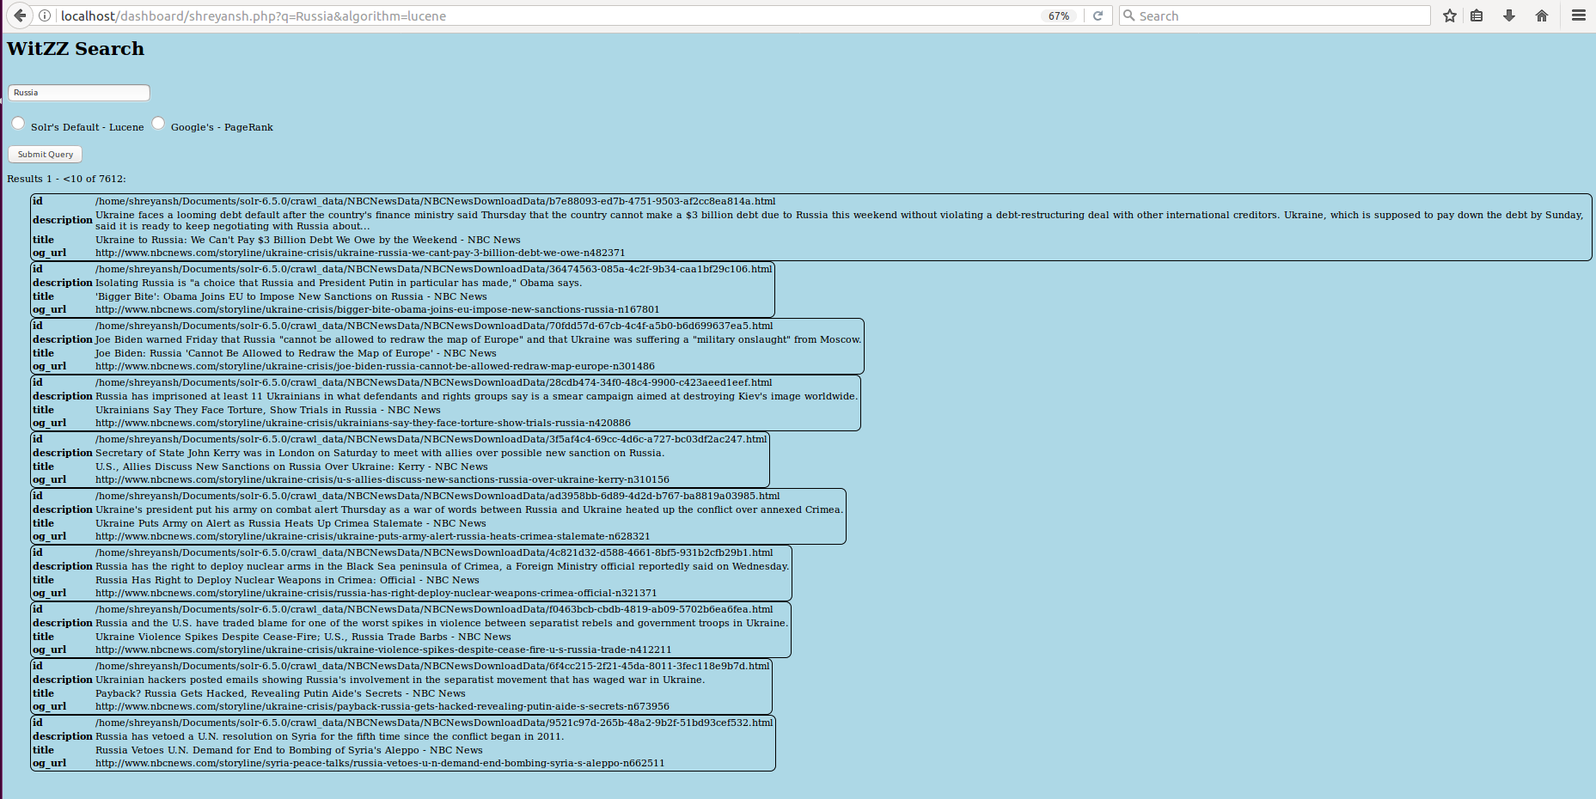

1. Russia – PageRank - Nation

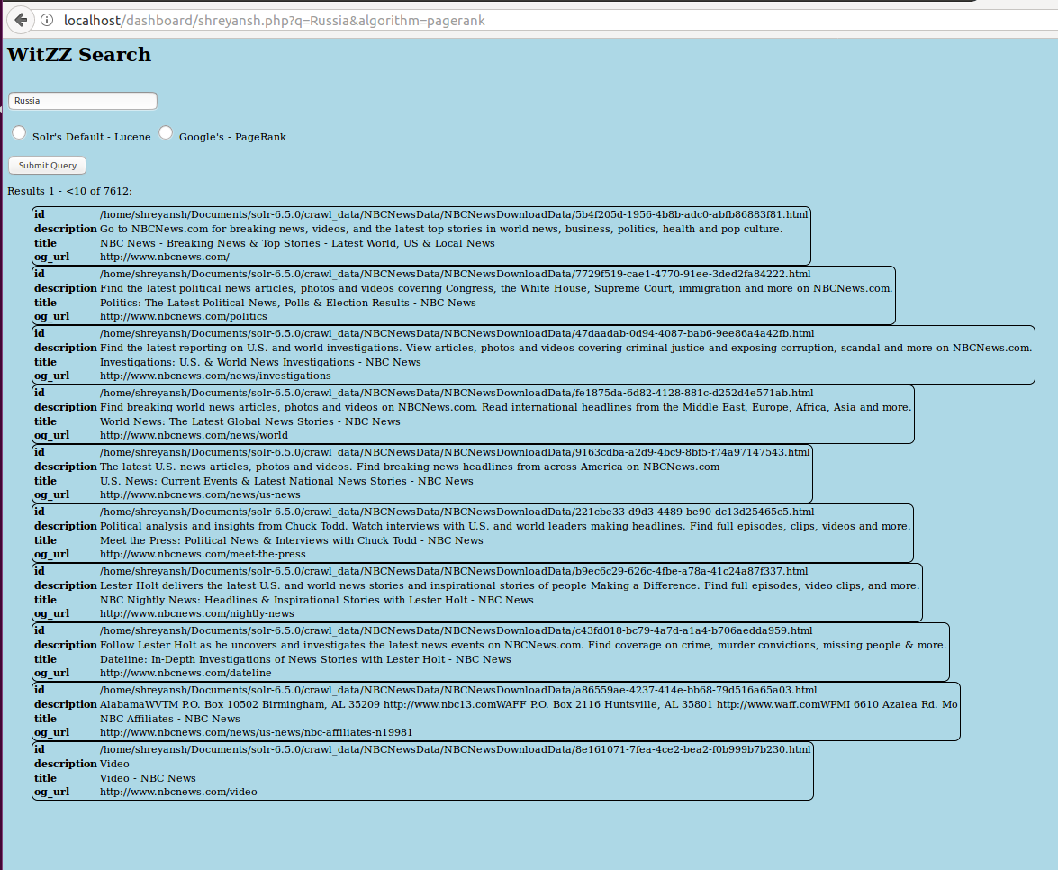

1. NASA – Lucene -Travel

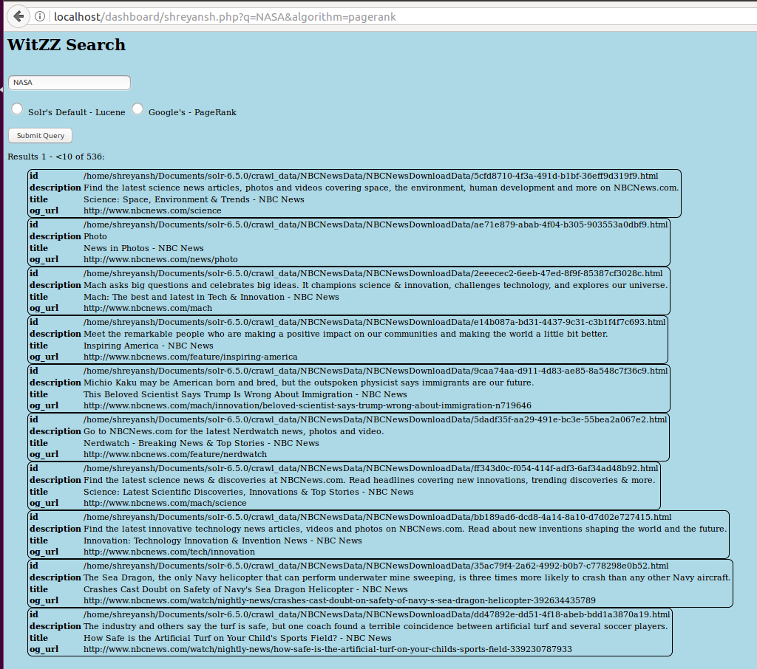

1. NASA – PageRank - Travel

